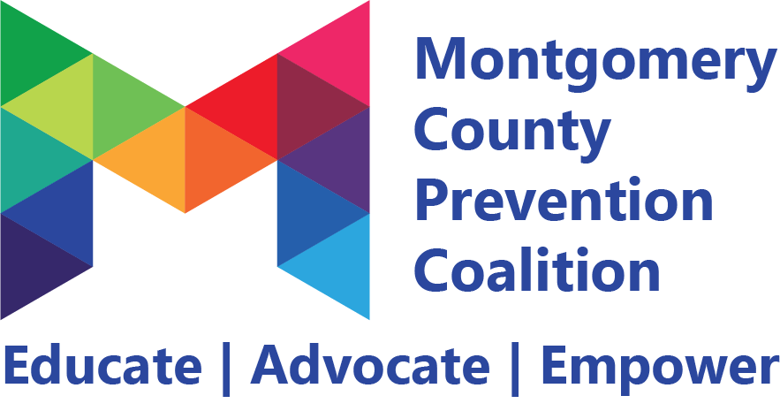

**Gaming & Gambling Strategic Action Plan**

**Objectives:** By September 29, 2028, keep the number of Montgomery County adults that are at risk for or experience a problem gambling disorder steady at 20% with the inclusion of sports betting data, as measured by the OMHAS Problem Gambling Survey.

Introduce gambling data to Panorama in 2024-2025 school year, with a 2% decrease by the end of the 2025-2026 school year.

**Strategy 1 - Provide Information**

**Educational presentations or other presentations of data (e.g., public announcements, brochures, dissemination, billboards, community meetings, forums, web-based communication).**

| **Measurable Activity** | **How will we measure this?** | **Who is responsible?** | **By When?** | **Progress (COMPLETED, IN PROGRESS, ON HOLD, NOT STARTED)** | **Project Team Needed?** |
| --- | --- | --- | --- | --- | --- |
| Create or utilize pamphlets on “Keeping Gaming Fun” and distribute at tabling events, reaching 2,000 individuals | Spreadsheet | Montgomery County Educational Services Center | May 2025 | IN PROGRESS |  |
| Create a list of alternate fundraising activities for schools, churches and organizations to use, distributing to 45 locations | spreadsheet | Montgomery County Educational Services Center | December 2025 |  |  |
| Create and distribute report sharing sports betting environmental scan results, distributing to 50 individuals | spreadsheet | Montgomery County Educational Services Center | December 2025 |  |  |
| Review Digital Detox website to ensure all material is up to date and make changes as necessary | Spreadsheet | Montgomery County ADAMHS Board | Annually | IN PROGRESS |  |

**Strategy 2 - Enhance Skills**

**Workshops, seminars or other activities designed to increase the skills of participants, members and staff needed to achieve population level outcomes (e.g., training, technical assistance, distance learning, strategic planning retreats, curricula development).**

| **Measurable Activity** | **How will we measure this?** | **Who is responsible?** | **By When?** | **Progress (COMPLETED, IN PROGRESS, ON HOLD, NOT STARTED)** | **Project Team Needed?** |
| --- | --- | --- | --- | --- | --- |
| Add gambling prevention information to 2 already-existing prevention programs | Provider statistics | Dayton Children’s Hospital, Montgomery County Educational Services Center | October 2025 |  |  |
| Create a 30-minute PD opportunities for schools/PTAs/parents regarding gaming and gambling prevention, reaching 50 individuals | Training Sign-In Sheets | Dayton Children’s Hospital, Miami Valley Gaming | December 2025 |  |  |

**Strategy 3 - Provide Support**

**Supporting people in activities that reduce risk or enhance protection (e.g., providing alternative activities, mentoring, referrals, support groups or clubs).**

| **Measurable Activity** | **How will we measure this?** | **Who is responsible?** | **By When?** | **Progress (COMPLETED, IN PROGRESS, ON HOLD, NOT STARTED)** | **Project Team Needed?** |
| --- | --- | --- | --- | --- | --- |
| Host a table at Hollywood Gaming during PGAM (March) and Responsible Gaming Education Month (September), distributing materials to 3,000 individuals | tally at tables | All Members | October 2025 | In Progress |  |
| Support 3 pop-up events or festivals where gambling occurs to ensure best practices | Committee report-outs |  | December 2025 |  |  |

**Strategy 4 - Enhance Access/Reduce Barriers**

**Improving systems and processes to increase utilization of systems and services (e.g., assuring healthcare, childcare, transportation, housing, justice, education, safety, special needs, cultural and language sensitivity).**

| **Measurable Activity** | **How will we measure this?** | **Who is responsible?** | **By When?** | **Progress (COMPLETED, IN PROGRESS, ON HOLD, NOT STARTED)** | **Project Team Needed?** |
| --- | --- | --- | --- | --- | --- |
| Promote already-created statewide resources (Time Out Ohio, Pause Before You Play, Gamban, Change the Game Ohio, etc.) reaching 500 individuals. | Spreadsheet/Social media analytics | Miami Valley Gaming | December 31, 2025 |  |  |
| Work with 5 schools to help them overcome barriers to offering gambling prevention curriculum for students. | Provider data | Dayton Children’s Hospital | June 30, 2025 |  |  |

**Strategy 5: Change Consequences**

**Changing the consequences for behavior that reduces risk or enhances protection against substance misuse (e.g., increasing public recognition for deserved behavior, individual and business rewards, taxes, citations, fines, revocations/loss of privileges).**

| **Measurable Activity** | **How will we measure this?** | **Who is responsible?** | **By When?** | **Progress (COMPLETED, IN PROGRESS, ON HOLD, NOT STARTED)** | **Project Team Needed?** |
| --- | --- | --- | --- | --- | --- |
| Create an incentive program to reward organizations that agree to change their fundraising practices resulting in 2 organizations changing their policies. | Report out at committee meetings |  | June 2025 |  | Breast Wishes Foundation is interested in this |
| Create a passport program for Digital Detox 101, with 20 individuals participating. | Spreadsheet with participating stores/activities | Montgomery County Educational Services Center | October 2025 | IN PROGRESS |  |

**Strategy 6: Change Physical Design**

**Changing the physical design or structure of the environment to reduce risk or enhance protection (Find areas of high substance use and create changes to lessen use, environment beautification/clean-up, increase lighting, add signage, implement positive messaging (murals, post-its, chalk art, etc.)**

| **Measurable Activity** | **How will we measure this?** | **Who is responsible?** | **By When?** | **Progress (COMPLETED, IN PROGRESS, ON HOLD, NOT STARTED)** | **Project Team Needed?** |
| --- | --- | --- | --- | --- | --- |
| Provide Problem Gambling Help Line signage to stores that did not have it based off the environmental scan, reaching 10 stores. | Spreadsheets | Montgomery County Educational Services Center | October 2024 | IN PROGRESS |  |
| Provide stickers or other items to display at bingo games across the community, reaching 5 locations. | Spreadsheets | Montgomery County Eduational Services Center | December 2025 |  |  |

**Strategy 7**

**Modify or change policies.**

**Advocating for change of school, local, state or national policies to decrease substance use and improve mental wellness (letter writing campaign, meeting with school or political officials, providing testimony)**

| **Measurable Activity** | **How will we measure this?** | **Who is responsible?** | **By When?** | **Progress (COMPLETED, IN PROGRESS, ON HOLD, NOT STARTED)** | **Project Team Needed?** |
| --- | --- | --- | --- | --- | --- |
| Create sample policy for schools to implement an age requirement for youth to assist with any gambling-related fundraising activities, supporting 10 schools. | Spreadsheet/report outs |  | June 2025 |  |  |
| Create and send a letter of support for the NCAA against college-level sports betting in Ohio. | Development/sending of letter |  | October 2024 |  |  |